##### 

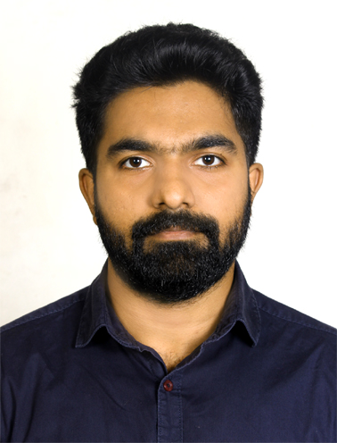

##### CURRICULUM VITAE

**Personal Details**

Name  **:** Jithin Joseph

Contact Number : +919961978369

E mail address : jitin423@gmail.com

Permanent Address : Kulangara (H), Villoonni PO, Kottayam Kerala,India

Nationality : Indian

Date of Birth : 18/12/1990

Gender : Malé

Religion : Christian

Marital Status : Married

Languages Known : English, Hindi, Tamil, and Malayalam

**Career Objective**

A talented individual seeks the position of accounting and finance in a reputed organization to maximize my learning and experience, while making a significant contribution to the success of the company. I would like to exploit my potential and sense of obligation for the benefit of organization.

**Professional Profile**

* A competent self-motivated professional with the ability to work independently and as part of a team within a highly pressured, fast moving environment with qualitative and enriching experience in the field of business.
* Efficient time management skills.
* Excellent inter-personal & written/oral communications skills.
* Ability to work efficiently & independently under pressure.

**Career Narration**

**July 2012 to December 2015**

**C A Technology Entertainments Pvt. Ltd, Kochi.**

**Marketing Executive**

**Job Profile:**

* Arrange the new video production
* Transport management
* Meeting with clients
* Social media management

1st August 2018 to 30th September 2019

Spice Foods Pvt Ltd, Brisbane, Australia.

**Assistant Manager**

**Job Profile:**

* Stock management
* Meeting with clients
* Issue order for delivery
* Delivery management
* Sales

**1st March 2020 to Still working**

**Kulangara Traders,Villoonni,Kottayam.**

**Manager**

**Job profile:**

* Marketing
* Sales
* Delevery Management
* Accounts

**Academic Qualification:**

* Advanced Diploma in Business, Queensford College,Brisbane,Australia(03/07/2017-01/07/2018).
* Diploma in Business, Queensford College,Brisbane,Australia (19/09/2016 -19/03/2017).
* B.E.in Electronics and Communication Engineering,SMCET,Sivaganga,T.N.,India

(01/09/2008-30/06/2012).

* HSE Board – Plus Two Science(2006 -2008), St. Ephrem’s HSS, Mannanam, Kottayam, Kerala.
* SSLC (2006), St. Ephrem’s HSS, Mannanam, Kottayam, Kerala.

**Key Skills**

* Ability to work well in a fast paced environment.
* Excellent leadership and team development skills.
* Good communication skills
* Good presentation skills.

**Declaration**

I hereby declare that the above stated information is true to the best of my knowledge.

Date:  **JITHIN JOSEPH**

Place: